|  |
| --- |
| Close-up image showing the leaf-sides of two oversized books side-by-side on a bookshelf, with additional books in soft focus background |
| Samkary Parmaga  Exam on level2 |
| |  |  |  | | --- | --- | --- | | Writed by: | Hamada Mahmoud Hamada | Basic Python | |

Note: Before starting, the exam is 5 minutes long and has 10 questions. If the person closes all the questions, he will get a 50% discount. If he closes it after the appointed time, he will get a 25% discount. The entire exam is multiple-choice questions.

1. When a specific word “love” is found in a variable that contains the sentence “I love you,” what is the appropriate Method to use?
2. Index
3. Find
4. Replace
5. a and b
6. When you use consecutive conditional cases or use a condition within another condition if the first condition is met, What is the name of this process?
7. Comparison
8. Short hand if-else
9. Nested if
10. Logical operator
11. What is the process that checks the value and type of a variable?
12. !=
13. ===
14. !==
15. ==
16. When we check more than one condition or if it is checked that all the conditions are true, we use the operation.....
17. And
18. Or
19. Not
20. No thing
21. What operation reverses the result, returning False if the result is true?
22. And
23. Or
24. Not
25. No thing
26. What is the comments?
27. Ignored the condition by interpreter
28. Ignored the code by compiler
29. Ignored the code by interpreter
30. Ignored the condition by compiler
31. Guess output:

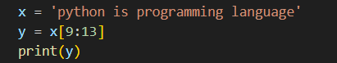

1. Pro
2. Is pro
3. _Pro
4. prog
5. Guess output:

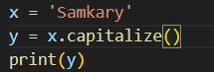

1. samkary
2. SAMKARY
3. Samkary
4. No thing
5. What is the command used to execute a block of code if the same condition is false?
6. If
7. Elif
8. Else if
9. else
10. Guess output:

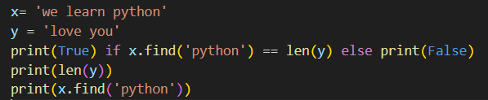

1. False,8,9
2. True,8,8
3. False,9,8
4. False,8,10

*Note: (_) is a space

Finish the Exam